LDR (Light Dependent Resistor)

Based water level control circuit

# What is LDR

An LDR is a component that has a (variable) resistance that changes with the light intensity that falls upon it. This allows them to be used in light sensing circuits.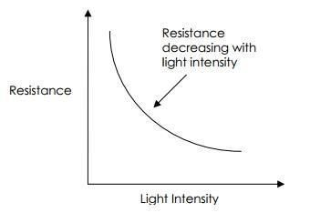

The most common type of LDR has a resistance that falls with an increase in the light intensity falling upon the device (as shown in the image above). The resistance of an LDR may typically have the following resistances:

Daylight

= 5000Ω

Dark

= 20000000Ω

You can therefore see that there is a large variation between these figures. If you plotted this variation on a graph you would get something similar to that shown by the graph shown above.

## Applications of LDRs

There are many applications for Light Dependent Resistors. These include:

Lighting switch

The most obvious application for an LDR is to automatically turn on a light at a certain light level. An example of this could be a street light or a garden light.

Camera shutter control

LDRs can be used to control the shutter speed on a camera. The LDR would be used to measure the light intensity which then adjusts the camera shutter speed to the appropriate level.

## Example - LDR controlled Transistor circuit

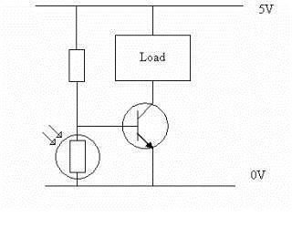

The circuit shown above shows a simple way of constructing a circuit that turns on when it goes dark. In this circuit, the LDR and the other Resistor form a simple 'Potential Divider' circuit, where the centre point of the Potential Divider is fed to the Base of the NPN Transistor.

When the light level decreases, the resistance of the LDR increases. As this resistance increases in relation to the other Resistor, which has a fixed resistance, it causes the voltage dropped across the LDR to also increase. When this voltage is large enough (0.7V for a typical NPN Transistor), it will cause the Transistor to turn on.

The value of the fixed resistor will depend on the LDR used, the transistor used and the supply voltage.

# Image of LDR

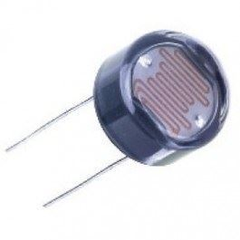

Figure

# Symbol of LDR

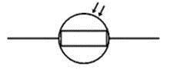

Figure LDR Circuit Symbol

# Water level control

## How level controller will work:

When Pump is switched on three LED and LDR (Light Dependent Resistors) circuits will get energized. LDR will get light through transparent PVC pipes from LED light on the other side of the pipe. Expecting the water is transparent. Inside pipe we will put one plastic ball or floatable bottle. When water level will rise the object inside the pipe also will rise. As the object floats, in-between the LED and LDR lights from LED will be blocked and LDR will get high resistance and consequently transistor (NPN) circuit will get activated (switched ON). Similarly, all other level where LDR is installed will give a signal for each LDR. When all level LDR gets activated pump is switched OFF. But LED lights are kept ON for checking the falling direction of floating object. Once again when light is blocked by the object it registers the LDR level signal until all three LDRs are confirm that the object falls through all three levels. Then it starts the pump again and cycle goes on.

Note: Alterative Ultrasonic level sensor

<http://www.circuitstoday.com/water-level-indicator-arduino-ultrasonic-sensor>